Projectile Motion Lab Handout

Question: Projectile Motion: Which variable affects the horizontal displacement of a projectile the most?

Introduction
Projectile motion is defined as the flight of an object near the earth’s surface under the action of gravity alone. We have all see projectile motion at one point in time. Over 500,000 years ago, the first known humans attached stones to sticks to create spears for hunting. The laws of projectile motion govern the path that a spear follows once it is thrown so understanding the factors that affect projectile lead to creation of better spears and more successful hunts. Understanding the factors that govern projectile motion also enabled people to build new tools for launching projectiles that could travel further in the air and hit targets with great accuracy, such as bows and arrows, the trebuchet, and cannons. Today, people who understand the factors that influence projectile motion, as professional athletes such as basketball and soccer players do, earn the respect of many fans and can earn large salaries.

In science, the modeling of projectile motion was of large importance and two great thinkers published works related to the topic. Aristotle’s view was that an object in flight followed a straight line until it “lost its impetus” and abruptly fell to the ground. Over 1600 years later, Galileo took up the task of studying projectile motion once more and published his results in the Dialogues of the Two New Sciences in 1638.

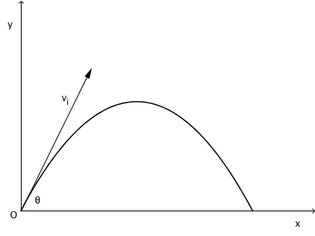
Figure 1. Projectile Parabola
When a projectile is in flight, we assume that gravity is the sole force acting upon it. The path of a projectile is a curve called a parabola, as shown in Figure 1. The object in flight will have horizontal and vertical components to its velocity at any given time. While scientists recognize that air resistance does affect the flight of a projectile, under most circumstances the effect of air resistance can be ignored. When we ignore air resistance, the horizontal component of velocity is governed by the horizontal component of the initial velocity and the vertical component of velocity is governed by the acceleration due to gravity.

People often want to be able to predict where a projectile will land after its launched. For example, hunters, athletes, and engineers can all benefit from understanding how different variables affect projectile motion. There are a number of variables that may, or may not, affect the motion of projectile. These variables include the launch angle (denoted as $θ$), the initial velocity of the projectile, the height of the initial launch, and the mass of the projectile. Some of these variables may also interact with each other so the effect of any one variable may differ depending on the value of another variable. People therefore need to not only understand how these variables affect the motion of a projectile but also how they interact with each other in order to understand where a projectile will land after it is launched. Through experimentation, practice, and careful study, you can gain insight into the affects of these parameters on objects in flight.

The Inquiry Task
Use what you to know about projectile motion to design and carry out a series of experiments to determine which variable has the biggest impact on the hang time of a projectile.

The guiding question of this investigation is,
Which variable affects the horizontal displacement of a projectile the most?

Materials

You WILL USE the projectile motion simulator found at:
http://www.physicsclassroom.com/Physics-Interactives/Vectors-and-Projectiles/Projectile-Simulator

Step 1: Designing and Carrying out an Investigation
In order to answer the guiding question, you will need to design and carry out several different experiments. Each experiment should look at one potential variable that may or may not affect the hang time of a projectile. Some potential variables include the initial angle, initial velocity, the height of the initial launch, and the mass of the object. To accomplish this task, you must determine what type of data you will need to collect, how you will collect it, and how will you analyze it before you begin.

To determine what type of data you need to collect think about the following questions:

- What variables can you test using the simulator?
- What is your dependent variable ?
- What will you hold constant?

To determine how you will collect your data, think about the following questions:

- What range of values are available for your variables and how will you choose your values ?
- How will you keep track of the data you collect?
- How will you organize your data into data tables?

In order to determine how you will analyze your data think about the following questions:

- What graphs will you plot to make sense of your data ?
- What observations will you make about the trends seen in each of the graph?

Step 2: Experimental Design
Write out the experimental design using the given template .
Save the file as Projectile Design_first name_lastname. Upload it to edgenuity.
Experimental Design Template

Step 3: Feedback by Instructor

Your instructor will review your experimental design and provide feedback to you. You will have a chance to revise your initial design’. You might need to gather more data or design a way to test one or more alternative claims as part of this process. Remember, your goal at this stage of the investigation is to develop the best argument possible. Use the feedback, tocollect sufficient and relevant data that will help you write a complete report. . Evaluate your report with the rubric given below to see if you meet the criteria . Save your report as Submit your report to edgenuity. ( save the file as Projectile CER_firstname_lastname)

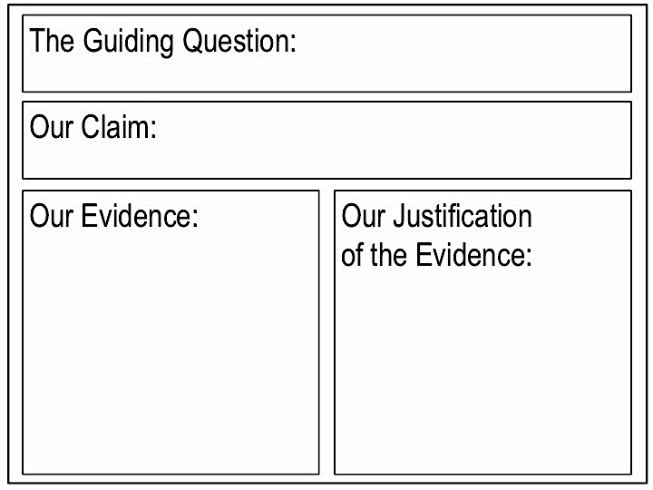
Figure 2. Argument Presentation on a Whiteboard
Step 2: CER Argument
Once you have finished collecting and analyzing your data, you will need to develop an argument. Your argument needs to include a claim, evidence to support your claim, and a justification of the evidence. The claim is your answer to the guiding question. The evidence is an analysis and interpretation of your data. Finally, the justification of the evidence is why you thinks the evidence matters. The justification of the evidence is important because scientists can use different kinds of evidence to support their claims. You will create your argument on a CER template.

