GUIDED NOTES: MODULE 7 EINSTEIN’S FALLS FVS PHYSICS A
INSTRUCTIONS: These are some of the essential driving questions on each of the lessons you will be learning in this module. On finishing the lesson, you may fill this up as an effective way of summarizing what you learnt in this lesson. If you cannot write the answers in your own words, perhaps you should revisit the lesson again. Use these guided notes to self-evaluate and relearn as necessary.

Lesson | Essential Questions | Your notes
7.01 ATOMIC THEORY | History of Atom Models:  A. Dalton’s theory
 | B. Thomson’s model
 | C. Rutherford’s discovery and model
 | D. Bohr’s model
 | E. Chadwick’s discovery
 | What are ions? How are they formed?
 | What are isotopes? How are the isotopes of an element similar and different to each other?
 | Define atomic number (Z) and mass number (A).
 | What is the role of valence electrons in chemical reactions?
7.02 | What does Einstein’s E= mc2 equation mean?
 | Explain with evidence the dual nature of light- how it is both a particle and a wave.
 | How can you calculate the Debroglie wavelength of a particle?
 | What are photons?
 | What are some common characteristics of electromagnetic waves?
 | How do you calculate the energy of a photon using its frequency? Using its wavelength?
7.03 | What is photoelectric effect?
 | What factors can affect the photoelectric current and how?
 | What is the photoelectric equation?
 | Define the terms work function and threshold frequency.
 | Explain the stability of a nucleus in terms of the 2 forces- electrostatic and nuclear force
 | What is mass defect?
 | What is binding energy?
 | How can you calculate the binding energy per nucleon of a nucleus Li 7whose mass defect is 0.04213 u
 | What is an atomic mass unit?
7.03 | Write down the general equations of alpha, beta and gamma decay.
 | Compare and contrast the mass, charge and ionizing power of the three radiations
 | Compete the following equations and identify if it is alpha, beta or gamma decay | 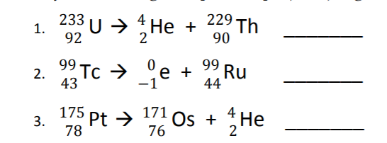  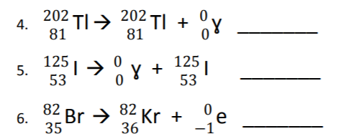
7.04 | What are some harmful effects of ionizing radiation?
 | What is half life?
 | What is the equation to calculate half-life?
7.05 | Compare and Contrast Nuclear Fission and Fusion.( be thorough in your comparison)
 | Research and identify how a fission reaction is a chain reaction
 | Research and explain why fusion reactions are called thermonuclear fusion.

