Behavior of gases:
- Boyles Law relates Pressure and Volume when temperature is CONTANT
  - As pressure increases volume will decrease
  - As pressure decreases volume will increase
- Charles Law relates Temperature and Volume when pressure is CONSTANAT
  - As temperature increases volume increases
  - AS temperature decreases volume decreases
- Gay-Lussac’s Law or the Pressure law relates Temperature and Pressure when Volume is CONSTANT
  - As temperature increases pressure increase
  - As temperature decreases pressure decreases
Combined Gas Law (three variables, nothing constant)
Use this formula: P₁V₁T₂ = P₂V₂T₁

Set up every problem by identifying the #1 variables (initial conditions) and the #2 Variable (final conditions). Only 1 will be missing! That is what you solve for.

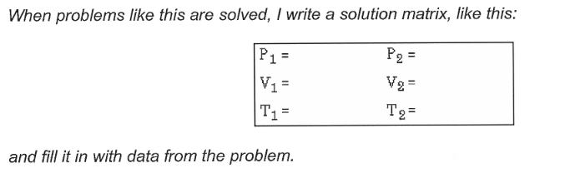
Example problem:
A gas with a volume of 4.0L and a temperature of 275K is initially at a pressure of 1.5 atm. If the temperature decreases to 225K and the volume increases to 5.5L what is its new pressure?
Step 1: Set up your matric and fill it in with your given variables:

P₁ = 1.5 atm
V₁ = 4.0 L
T₁ = 275K
P₂ =X (what I solve for)
V₂ = 5.5 L
T₂ = 225 K

STEP 2: write the formula then substitue in the variables: **be careful temperature is flipped!
P₁V₁T₂ = P₂V₂T₁
(1.5)(4.0)(225) = (X)(5.5)(275)
Step 3: solve
1350 = 1512.5 (X) simplify by multiply all numbers on both sides
0.89 atm = X Solve for x by dividing both sides by 1512.5
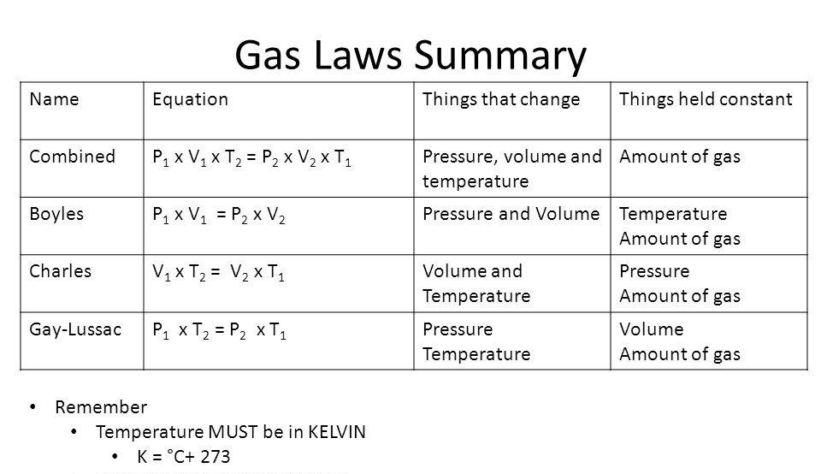

**Amount of gas = # moles

IDEAL GAS LAW HELP: https://www.khanacademy.org/science/physics/thermodynamics/temp-kinetic-theory-ideal-gas-law/a/what-is-the-ideal-gas-law
PV=nRT

DALTONS LAW OF PARTIAL PRESSURE: https://www.khanacademy.org/science/chemistry/gases-and-kinetic-molecular-theory/ideal-gas-laws/a/daltons-law-of-partial-pressure

Key points
- The pressure exerted by an individual gas in a mixture is known as its partial pressure.
- Assuming we have a mixture of ideal gases, we can use the ideal gas law to solve problems involving gases in a mixture.
- Dalton's law of partial pressures states that the total pressure of a mixture of gases is equal to the sum of the partial pressures of the component gases:
...P Total =P gas 1 +P gas 2 +P gas 3 ...P, start subscript, T, o, t, a, l, end subscript, equals, P, start subscript, g, a, s, space, 1, end subscript, plus, P, start subscript, g, a, s, space, 2, end subscript, plus, P, start subscript, g, a, s, space, 3, end subscript, point, point, point
- Dalton's law can also be expressed using the mole fraction of a gas, xxx:
x1P gas 1 =x 1 P Total

